INHEAL: Innovation in
Health Literacy
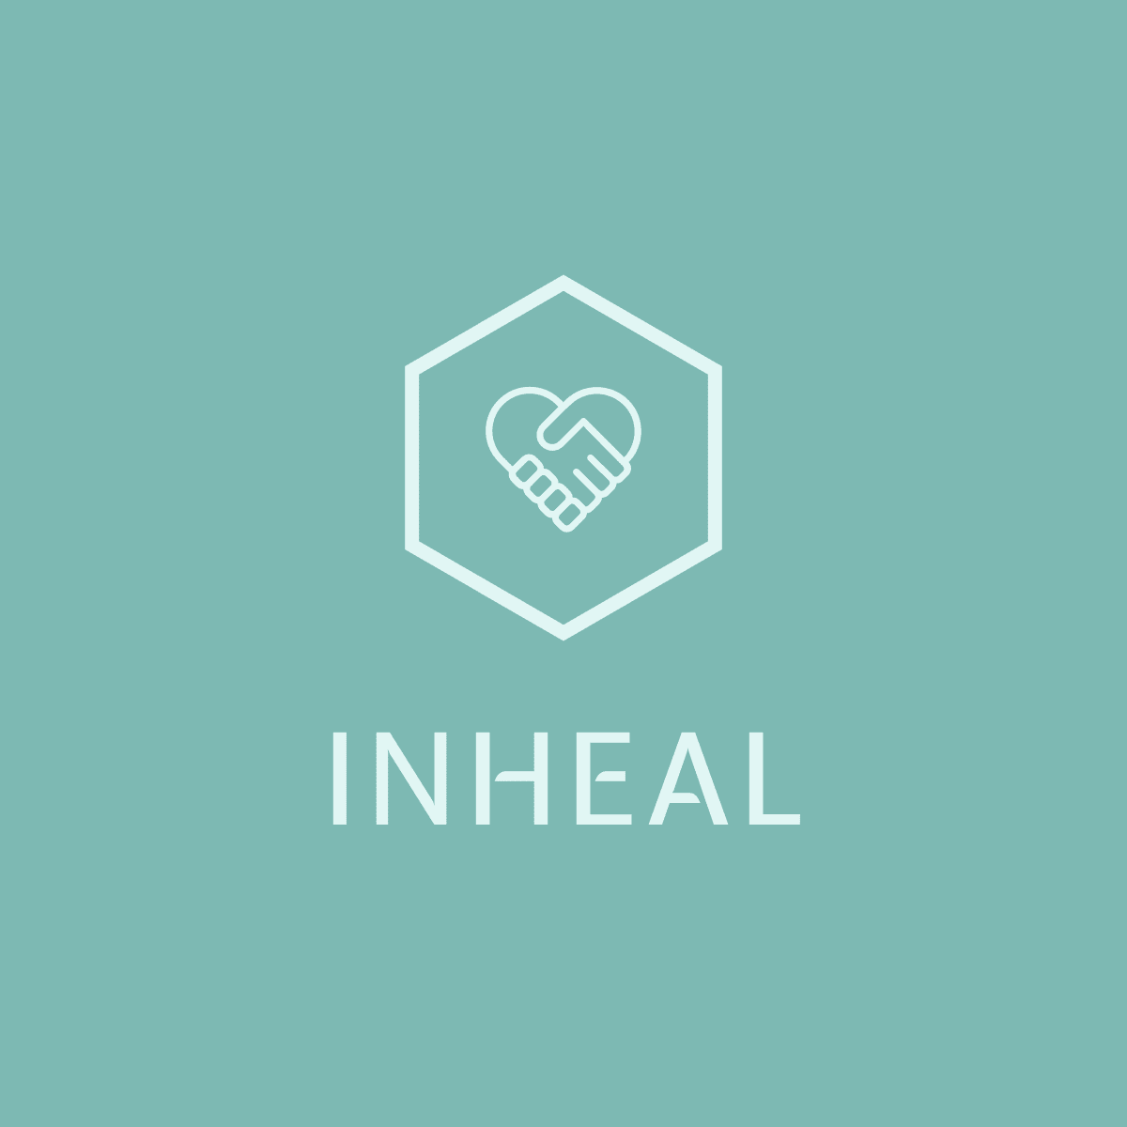
National Analysis in Hungary,
English Version.

INHEAL: Innovation in Health Literacy
Deliverable 1: Analysis
Desk research: Hungary, April-May 2022

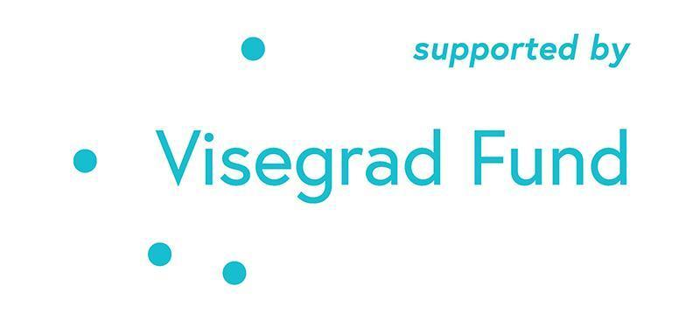

The project is co-financed by the Governments of Czechia, Hungary, Poland, and Slovakia through Visegrad Grants from International Visegrad Fund. The mission of the fund is to advance ideas for sustainable regional cooperation in Central Europe.
INHEAL: Innovation in Health Literacy
Deliverable 1: Analysis - Country desk research
Identifier | MedicalScan Ltd.  Hungary
Time horizon | Specific focus on 2015-2022.
Research objectives | Research objectives of national desk research performed in Hungary were the following:  - To identify the real, relevant gaps and seniors’ learning needs (knowledge and skills) of accessing health information and services including special focus on the use of ICT based methods;  - To determine the current state of play measures and practices adopted at the national, regional or local levels to enhance accessing (digital) health information and services.
Research items | Desk research was realized in April-May, 2022 for the Hungarian analysis.  The search for relevant information was done by using the following combination of words:  - Digitalis egészségügyi ismeretek (digital health literacy)  - Egészségügyi tudás/ismeret (knowledge/skills)  - Idősödés (aging)  - Betegtájékoztató (Patient information leaflet)  - Egészség/COVID-19 (health/COVID-19)  - Idősek, időskorúak (seniors/older people)

Research body

Demographic and health overview
The population of Hungary is ageing. This is more due to low birth rates than an increase in life expectancy. As a result, the size of the population is decreasing. In 1990 the 13% of population was above age 65 year, in 2020 it achieved 20%.

The life expectancy at birth in Hungary grew from 71.9 to 75.7 years between 2000 and 2020. Despite this, in 2020 it remained almost five years below the EU average. On average, Hungarian women live almost seven years longer than men. The mortality rates from preventable causes were the highest of any EU country before the pandemic, highlighting the need to reduce behavioral and other risk factors. Approximately half of all deaths are attributable to behavioral risk factors. One quarter of all deaths in 2019 could be attributed to dietary risks, which is above the EU average (17%). Tobacco consumption, including direct and second-hand smoking, caused a further 21% of all deaths, with around 7% attributable to alcohol consumption and 2% to low physical activity. Deaths from treatable causes were also far above the EU average, reflecting issues with the quality of health service. Ischaemic heart disease and stroke are the leading causes of death, accounting for a third of all registered deaths in Hungary in 2018. Among cancers, lung cancer is the most frequent cause of death, followed by colorectal, pancreatic and breast cancer.

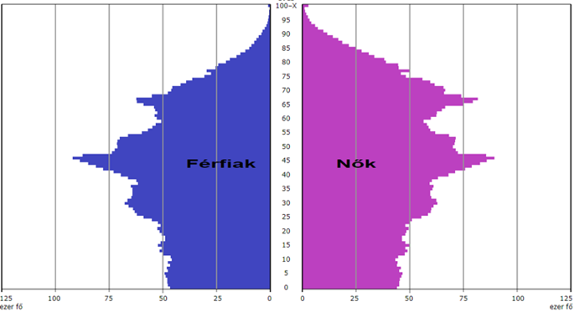

According to forecasts, the number of people over the age of 65 in Hungary will reach a 29% of the population, indicating that almost one in three is expected in 40 years a person will be older than 65 years (Monostori, 2015). These predictions also point to the elderly simultaneous increase in the number and proportion of Economic actors face to look at the appearance (and retention) of a large number of older workers resulting from this situation. According to Móré (2015), the older generations have skills and competencies which can be well utilized in terms of productivity.

Definition: dependence rate of the elderly population: population aged 65 and over as a percentage of the population aged 15-64. Dependency rate: the population aged 14 and under and the population aged 65 and over as a percentage of the population aged 15-64. Aging index: the population aged 65 and over as a percentage of the child population aged 14 and under.
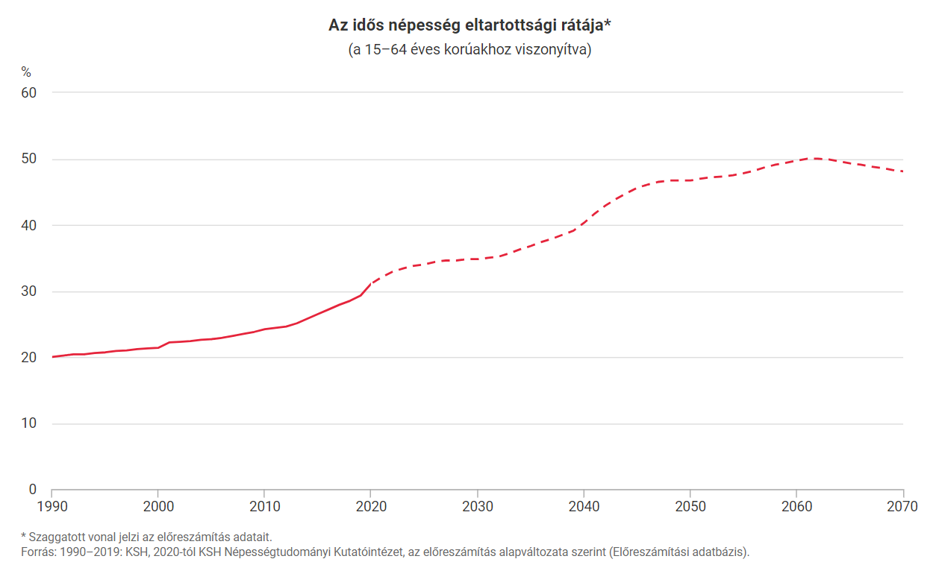
In Hungary, the old-age dependency ratio increased from 20.0% in 1990 to 30.3% in 30 years, ie 303 people aged 65 and over reached one thousand active age groups (15–64 years). The ratio is worse if we project only the actual working age population, the population between 20 and 64 years old. In 2020, there were 328 elderly people aged 20-64. The old-age dependency ratio is expected to increase steadily compared to the previous period, reaching around 50% in 2062, according to the current baseline population projection, ie 500 people aged 65-64 will be aged 65 and over. Thereafter, this rate is expected to decline to 48% by 2070. With increasing life expectancy, there are more and more elderly people in modern societies, including Hungary. The increase in their numbers and proportions within the population is a general phenomenon, which is placing an ever-increasing burden on social welfare systems. The old-age dependency ratio does not take into account the number and proportion of children, it indicates the current state of aging.

Nearly 40% of adults reported having at least one chronic condition in 2019. In recent years there is an increase in the rate of health expenditure growth: in 2013-19 the average annual growth rate in health spending per capita was 2.9 % compared to negative growth of -0.5 % in 2008-13.

Health expenditure as% of GDP [%] *

Despite the improvement of the last 15 years, life expectancy in Hungary is still years behind those of most EU countries. Significant differences can be observed in the health status of different socio-economic groups due to exposure to risk factors. higher exposures and inequalities in access to health care. The Hungarian health system is underfunded, with per capita health spending only about half the EU average.

In 2018, life expectancy in Hungary was 7.3 years lower than the Spanish life expectancy and 4.8 years lower than the EU28 average.
The average life expectancy in the EU28 was 78.3 years for men and 83.6 years for women, which was 5.6 years higher for men and 4.0 years higher for women compared to Hungary. In 2018, life expectancy at age 65 in Hungary was 3.2 years lower than the EU average, which was 18.2 years for men and 21.5 years for women. Hungarian men aged 65 could expect to live 3.6 years and women 3.0 years less than the EU average.
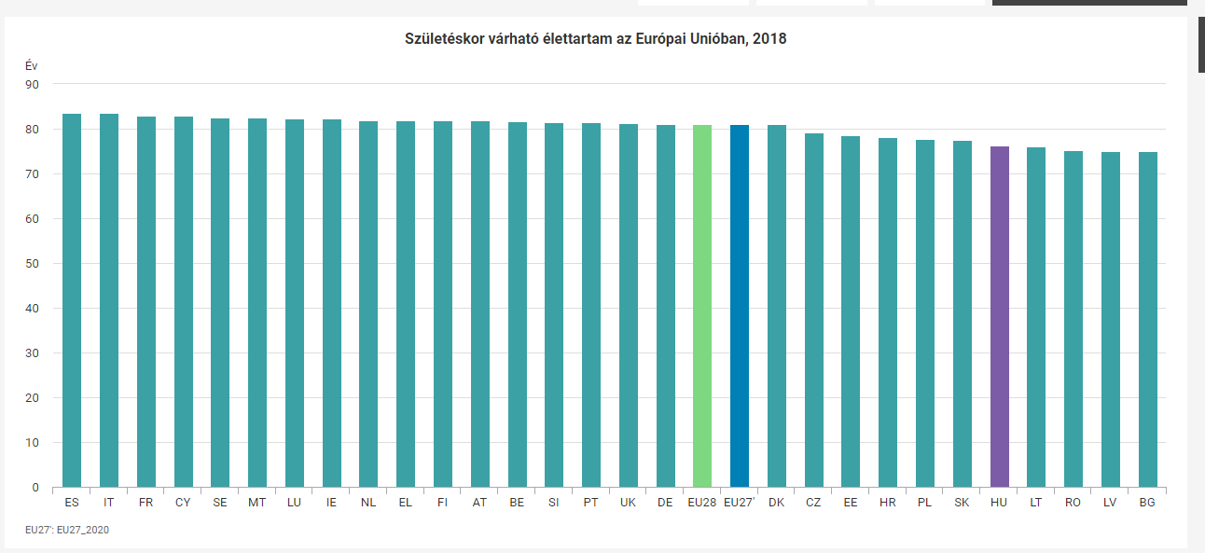

Hungarian women - significantly below the European average - live on average 18.5 years, and men still live 15 years over the age of 65, but only 6.5 years of this are the number of healthy life years. All this means that their care after the age of 70 places a significant burden on social security.
There are big differences in the numbers in some regions of the country, which also means that a different solution will have to be found to care for the elderly in the Budapest agglomeration, where their proportion is the lowest, and in Szabolcs-Szatmár-Bereg county, where it is the highest.

I. National Context of Health Literacy among Senior Citizens

Health Literacy definition, general characteristics

The health literacy (HL) is a term introduced in the 1970’s and a development can be traced in the field of it. For some time most emphasis was given to health literacy as the ability to handle words and numbers in a medical context, and in recent years the concept is broadening to also understanding health literacy as involving the simultaneous use of a more complex and interconnected set of abilities, such as reading and acting upon written health information, communicating needs to health professionals, and understanding health instructions and of increasing importance in public health and healthcare.
The definition by the American Medical Association, the Institute of Medicine and WHO are cited most frequently in the eligible literature.
WHO (1998) - "The cognitive and social skills which determine the motivation and ability of individuals to gain access to understand and use information in ways which promote and maintain good health”
American Medical Association's (1999) - "The constellation of skills, including the ability to perform basic reading and numeral tasks required to function in the healthcare environment"
Institute of Medicine (2004) - "The individuals' capacity to obtain, process and understand basic health information and services needed to make appropriate health decisions"
The US Healthy People 2030 program provides new definition addressing both personal health literacy and organizational health literacy.
Personal health literacy is the degree to which individuals have the ability to find, understand, and use information and services to inform health-related decisions and actions for themselves and others.
Organizational health literacy is the degree to which organizations equitably enable individuals to find, understand, and use information and services to inform health-related decisions and actions for themselves and others.
It is important to distinguish health literacy from literacy in general. In recent years four understandings of literacy have appeared from the debate of the notion:
1) literacy as an autonomous set of skills;
2) literacy as applied, practiced and situated;
3) literacy as a learning process;
4) literacy as text.
The focus is furthermore broadening so that literacy is not only referring to individual transformation, but also to contextual and societal transformation in terms of linking health literacy to economic growth and socio-cultural and political change

Within the process of desk research we have not found a specific national description and/or expectation for the given context. Health literacy is more an educational item/curriculum for the different types of mental/health education colleges/universities etc. for doctors, nurses, social workers and so on rather than a defines expectation for general health education. There is no doubt in Hungary that health-conscious behavior is related to health status. In addition to physical health, you are maintaining mental and emotional well-being where appropriate, its acquisition or even recovery is of paramount importance in active aging.

Health literacy includes the skills needed to absorb basic health information and are determinants of health decisions. It would be important to take into account the health literacy of the target groups in the process of health promotion, disease prevention and treatment. In a comparative study of eight European countries, one-tenth of those surveyed had an inadequate level of health education, and nearly half had a problem level.

Integrated conceptual model of health literacy

In 2012 European working group based on comprehensive literature review proposed a model which integrates the medical and public health views of health literacy. In their understanding the health literacy is regarded an asset for improving people's empowerment within the domains of healthcare, disease prevention and health promotion and four dimensions where:
(1) Access refers to the ability to seek, find and obtain health information;
(2) Understand refers to the ability to comprehend the health information that is accessed;
(3) Appraise describes the ability to interpret, filter, judge and evaluate the health information that has been accessed;
(4) Apply refers to the ability to communicate and use the information to make a decision to maintain and improve health.

The matrix with four dimensions of health literacy applied to three health domains

 | Access/obtain information relevant to health | Understand information relevant to health | Process/appraise  information relevant to health | Apply/use information relevant to health
Health care | Ability to access information on medical or clinical issues | Ability to understand medical information and derive meaning | Ability to interpret and evaluate medical information | Ability to make informed decisions on medical issues
Disease prevention | Ability to access information on risk factors for health | Ability to understand information on risk factors and derive meaning | Ability to interpret and evaluate information on risk factors for health | Ability to make informed decisions on risk factors for health
Health promotion | Ability to update oneself on determinants of health in the social and physical environment | Ability to understand information on determinants of health in the social and physical environment and derive meaning | Ability to interpret and evaluate information on health determinants in the social and physical environment | Ability to make informed decisions on health determinants in the social and physical environment

The model serves as a basis for developing health literacy enhancing interventions and provide a conceptual basis for the development and validation of measurement tools, capturing the different dimensions of health literacy within the healthcare, disease prevention and health promotion settings.

National Health Literacy studies overview: evolution of health literacy assessment tools and measuring methods, trends across years, and status quo, special focus on senior citizens.

In 2016 Koltai and co performed a study with the aim to present the extent of the practical health literacy in the Hungarian society and its place in international comparison.

The research both in terms of content and methodology replicated the Health Literacy Survey EU which was developed and validated by the HLS-EU Consortium based on integrated conceptual model of health literacy. The Hungarian team used the HLS-EU 47 questionnaire and index calculation methods, internationally validated threshold levels for the general health literacy index and sampling aspects in order to have comparable data with 8 countries (Austria, Bulgaria, Greece, Ireland, the Netherlands, Poland, Germany, Spain) using identical methodology. Based on the results, we can say that although the understanding of health in Hungary is similar to the trends in other European countries, its extent somewhat lower than that. More than half of Hungary’s 16 or older population has only limited health literacy – Bulgaria was the only country, where the average of the general health literacy index was significantly lower than in Hungary. In each of the three main indices (health care, prevention and health promotion), very low proportions of Hungarian respondents achieved an excellent level of health literacy, while the proportion of those with inadequate health literacy is among the highest in international comparison.

General HL index comparison
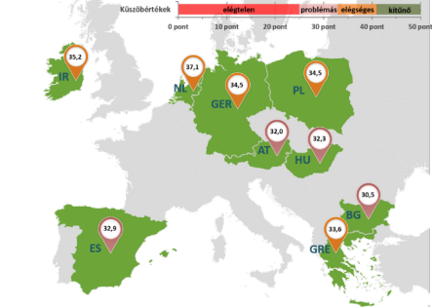

In 2015, Papp-Zipernovszky et al measured the health education of the population. In their study, sampling was done in two waves: convenience first by sampling and then specifically that no, age and a representative sample by educational attainment available to them. In the survey, S-TOFHLA and Hungarian validation of the Chew test was performed.

Based on the Short-Test of Functional Health Literacy reading scores, participants were categorized into three groups: 8% had inadequate, 6% marginal and 86% adequate health literacy levels.

In the study sample, 14.3% of the respondents had either inadequate or marginal health literacy (8.3% inadequate, 6% marginal health literacy scores). The results are in accordance with the European outcomes of the S-TOFHLA, as in many countries the proportion of either marginal or inadequate health literacy was around 10 to 15%. For instance, in a study measuring the prevalence of limited functional health literacy in the UK, this proportion was 11.4%. The health literacy level in Hungary is the most similar to the outcomes of the French-speaking Swiss population. Moreover, based on the HLS-EU survey around 12.4% of the respondents showed inadequate health literacy, and further 35% problematic health literacy on average in the participating countries. In Hungary, based on the HLS-EU survey, 20% of the respondents possessed inadequate and 32% problematic health literacy, which is much higher than the 8.3% inadequate and 6% marginal health literacy proportions found in Papp-Zipernovszky et al’s study. This difference might be explained by the difference in the operationalization of health literacy between the studies: while the S-TOFHLA objectively measures functional health literacy, the HLS-EU survey is based on self-reported data and focuses on the cultural aspects and critical skills of health literacy.
Regarding the socio-demographic predictors, the results show that older participants possess a lower level of health literacy, which is in accordance with previous findings.
As chronically ill needs to use and understand health-related information on a regular basis, it is crucial to increase the health literacy level in this population.

The study published in 2020 was carried out within the framework of the EU-funded project IROHLA (Intervention Research on Health Literacy among the Aging population). IROHLA aimed to improve the health literacy of adults aged 50 years and older with poor health literacy in Europe. To gain insight into a range of perspectives of older adults and health professionals, a qualitative approach using focus group discussions (FGDs) was adopted. The Hungarian results are summarized in the table below.

Being in Control of Health and Well-Being
Theme | Subtheme | Findings (General and HU)
Interactions with health professionals | The consultation room | important setting
 |  | afraid to ask questions; professionals only respond; difficulties getting professionals’ attention
Quality of health care system | Healthcare system | Public, tax-funded health care system
 | Quality of care | Not being able to pay customary gifts is a reason to avoid healthcare
 | Affordability | healthcare is too expensive
 | Waiting lists | waiting lists for appointments are long
 | Coordination of care and information | lack of coordination, resulting in inefficiency
 |  | health information is not aligned
Everyday lives | Caring for oneself | pressure on family
 |  | fear of becoming a (financial) burden for family
 | Engaging in activities that support health and well-being | involvement in family life
 |  | engagement in organized activities

In Hungary, some older adults said they ask questions to their health professionals while others felt afraid to do so. In the latter case, participants reported that health professionals often did not respond to their silences. As a result, they felt health professionals do not take the initiative in explaining what is at hand. Rather, they only respond to questions asked by patients. A health professional confirmed he did not encourage dialogue with his patients.

As a result of this, the Hungarian participants felt they could not share their experiences and health problems fully with their health professionals. In line with this, a recurring issue in the discussions was how participants experienced difficulties with getting a health professional’s full attention. Many participants said, for instance, they try to get the doctor’s time and attention by bringing gifts in the form of a present or money. Overall, the Hungarian participants felt they were not taken seriously, not sufficiently informed, and reported they distrust health professionals in general.
In Hungary, several of the older adults articulated how a lack of affordability influenced their health care choices. Some older adults described they sometimes do not take their prescribed medications because they cannot afford them. Furthermore, they explained how they avoid making an appointment with a doctor because they cannot afford the customary gift. Several health professionals recognized this behavior and reported that such avoidance of care could worsen the long-term health of older adults.
Many participants experienced unclear directions for obtaining health services in hospitals and experienced long waiting lists for doctor’s appointments. These issues could have serious health consequences.
In addition to long waiting times, Hungarian adults also mentioned they experience problems with the coordination between specialists.
In Hungary, many participants also said they find the health information system too complex. The main problem identified was an excessive amount of health information that is insufficiently aligned across multiple channels. Consequently, ambiguous health messages and a lack of public trust in the overall health care system occurred.
To sum up, the participants reported the health care systems in which they must find their way as complex, expensive, and difficult to access. As a result, they often do not seek the care they know they would need. Also, although experiencing problems with navigating the health care systems first-hand, the participants did not feel empowered to change these systems but rather felt they had to endure them.

National Health Literacy statistics: health literacy levels among seniors across years and status quo; main gaps and issues identified by the latest studies (i.e. individual and system factors

In an international comparison, the proportion of the Hungarian population who report an unmet need for a medical examination or treatment is 1,5 times greater than the EU average. Among the V4s, the proportion of missed medical visits is lower in the Czech Republic, in Slovakia this proportion is similar to Hungary and 3 percentage points higher in Poland. Regarding the health behavior of the Hungarian population, it is a matter of concern that the population of Hungary is the second “most patient” in the EU, ie most people in Hungary postpone to see a doctor - four times as many as the EU average - because they trust that “they will heal on their own”. The picture is further aggravated by the fact that most people in Poland and Hungary refer to the lack of time, five times as much as the EU average.

Furthermore, based on the data of 2010–2018, a quarter of the population in Hungary feels limited in terms of everyday activities. In 2019, there was a methodological change in the survey of constraints, which makes it difficult to compare the latest data with the previous ones. According to 2019 data, 18% of the population aged 16 and over are not severely, but restricted and 7% are severely restricted. Women are 23% more likely to report being restricted. 4% of 16–24-year-old say they are limited, and this rate increases exponentially by age group, reaching 68% of those aged 75 and over.

Due to the importance of reading comprehension in modern societies, the Organization for Economic Co-operation and Development (OECD) has been conducting comprehension surveys every 4-5 years since 1994 among the adult population in the countries joining its surveys. Within each dimension, five levels of reading comprehension are distinguished, and consistently achieving level 3 means that one could thrive independently in everyday life in modern society.

According to the results of the comprehension survey in 2008, less than half of the Hungarian adult population performed at least level 3 in terms of prose comprehension, but the same was true for documentary and quantitative comprehension. In the problem-solving dimension, the situation was somewhat better, with “only” 40% of study participants performing below the expected level.

For some reason, Hungary has not participated in international surveys on adult comprehension or health education in recent years. Based on other indicators of the health status of the Hungarian population, it can be estimated that the general reading comprehension of the Hungarian population has not improved spectacularly compared to 2008, and accordingly it is unlikely that we belong to the forefront in terms of health education.

In recent years, there have been some attempts to measure health education in Hungary as well, but these were mostly preliminary, non-representative and small-sample preliminary studies, from the results of which no conclusions can be drawn regarding the health education of the adult population. An additional difficulty in health literacy surveys is that the data from individual method surveys only allow a comparison of the performance of those surveyed, as the uniqueness of the tasks used for the survey and the lack of fit to international scales make it very difficult to place the results in a national or international context.

As a survey conducted in 2015 found that about half of Hungarians did not have adequate health education, there would be a need for effective policy measures that would hopefully improve the health status of the population and the overburdening of the health care system.

National Strategy Path on Diseases Prevention, Health Protection, and Health Promotion: Priority Areas and Strategic Objectives

In the sector strategy, the “Strategy for Long-Term Care 2030” and the on the basis of the policy objectives set out in the five National Health Programs development programs to develop a complex package of measures option, some elements of which are the magnitude of the available resources, over time availability and the content and procedural framework governing its use providing the best possible conditions for their effective implementation, taking into account domestic or other program - e.g. RRF, operational programs, domestic budget, Switzerland Contribution, etc. - may be implemented.

Presentation of National Health Programs
- National Cancer Program
- National Circulation Program
- National Musculoskeletal Program
- National Mental Health Program
- National Child Health Program

Within this National program there is no specific reference about the elderly/senior population.

Existing and Developing Public Policies for increasing Health Literacy, special focus on their scope of action and impact on senior citizens’

The planned interventions in the field of public health have been identified along 2 pillars in a total of 9 sub-programs by the government:
The first pillar is the “Protection and development of the health of priority target groups.” Within this, a key target group is the seniors.
Due to the aging of society, the steady increase in the proportion of the elderly it is essential to improve the physical and mental health and quality of life of the elderly.
Since most of the health problems experienced by the seniors are not only a consequence of age, maintaining and improving the health of the elderly population and maintaining functional abilities is a primary task.
The protection and development of the health of the elderly requires methods that are tailored to the needs of the elderly group and support an active and a healthy lifestyle.
These methods could reduce the individual, family, and social burdens of aging by prolonging healthy life expectancy and expanding the range of people who can take care of themselves.

Hungary's comprehensive health screening program / 2010-2020-2030 (MÁESZ) / is our country’s largest humanitarian health program, which provides free of charge screening to the population, keeping in mind the importance of prevention with the most modern tools.
There is no need for a TAJ (Hungarian Public Health Insurance System) card to participate in the programs, so disadvantaged people can benefit from the opportunities provided by the program too. The program is implemented by the cooperation of 76 professional organizations and the consensual cooperation of the National Program for the Prevention and Treatment of Cardiovascular Diseases coordinated by the Association of Hungarian Medical Companies and Associations (MOTESZ) based on European Union directives. Between 2010 and 2021, the program successfully met its goals at the national level. It was present at 2,212 locations nationwide, carrying out the planned 8 million screenings at the same time, allowing more than 643,000 citizens to participate in the humanitarian form.

In the period of 2020-2025, Hungary's comprehensive health screening program focuses on children, young people, and families within the framework of the “Year of Prevention Children - Youth - Families”. This Program aims to helps as many Hungarian citizens as possible to learn about the improvement of their own health status, regardless of age, residence, or occupation, and to recognize the importance of prevention.

II. National Context of Digital Health Literacy among Senior Citizens

Broad scope of Digital Health (categories of tools and services)

According to the OECD report on the economic situation in Hungary (Economic Survey of Hungary 2021) Hungary lags in the use of information and communication technologies (ICT) (social media, cloud storage, high-speed broadband internet, big data analysis based on large databases), and the provision of broadband mobile data in Hungary is expensive compared to the OECD average.
Adaptation of digital technologies in smaller firms and the public sector are also lags other countries. A concern is high mobile internet prices, which reduce mobile broadband usage. In addition, businesses use high-speed broadband less than elsewhere. Low digital preparedness hinders the implementation of new technologies and the integration into national and international supply chains.
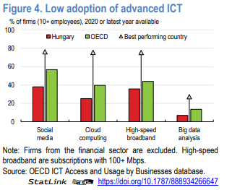
The COVID-19 epidemic has had a major impact on digital health, with an emphasis on the rapid and effective identification and prevention of suspected infections. The epidemic caused challenges in the treatment of the disease, but it also affected the further expansion of e-health services and increased the demand from patients and the care system.
As a result of the COVID-19 epidemic, remote consultation solutions have become part of the everyday care. The epidemic strengthened the link between primary and specialist care, had to be reduced the personal doctor-patient appointments. All of this has enhanced the role of digital healthcare and electronically accessible health records.

Between 2014–2020 the health care system including the patients, the healthcare professionals and the healthcare administration experienced the most intensive digital transformation in Hungary. The Electronic Health Services Area (EESZT) and the implementation of the EFOP1.9.6 priority project aimed the further development of this IT system. The project is ongoing, however major steps were completed by 2021.

The primary function of the EESZT is to store health data, documentation, and test results in a common repository. The data is available in digitalized form to rightsholders in the system.
During the visits, the right information is optimally accessible to the right person. The authorized physician, pharmacist easily and quickly can access all the relevant data of a given patient, in one place, 24 hours a day. Of course, the data stored about the patient is also available to the patient after their identification on the EESC's website an on the mobile application platforms.
An important function of the EESC is the electronic referral (eBeutaló), which is transmitted directly in the system between the doctor who issuing the referral and the doctor who performing the examination.
Another important function of the EESC is the electronic prescription (eRecept), which is often used by patients. The prescription written in the doctor's own system automatically becomes an eRecipe and is uploaded to a central repository from which it can be queried at any pharmacy.

During the pandemic, 33-35 thousand citizens registered to the EESZT every day, the number of inquiries initiated by doctors was 8.6 million in 2018, 17.6 million in 2019 and 30 million by the end of 2020, the proportion of electronic prescriptions was increased to 95%.
Digital solutions, telemedicine, and the central registration of large amounts of health data provide an opportunity for the Hungarian healthcare - in addition to improving efficiency and increasing patient satisfaction - to involve several possibilities that not previously present in the healthcare system, such as the use of large amounts of data in medicine or fast and direct connection of those involved in healing.

Digital Health Literacy definition, general characteristics

"E-health education refers to an individual's ability to search for, identify and assess the reliability of health information from the Internet and to properly manage or solve health problems through the knowledge they gain."
According to the Lily model of Norman and Skinner the eHealth literacy encompass the traditional literacy (basic ability to read and comprehend written text), information literacy (the ability to find and use information), media literacy (the ability to think critically about media content and context), computer literacy (the ability to use computers for problem solving) and scientific literacy (understanding how knowledge is created with its aims, methods, limitations, and politics), in addition to traditional health literacy. eHealth literacy has been defined as “the ability to seek, find, understand, and appraise health information from electronic sources and apply the knowledge gained to addressing or solving a health problem”. The eHEALS (eHealth Literacy Scale) was developed and validated in 2006 on Canadian adolescents and has been used most extensively as a subjective measure of eHealth literacy, showing little correlation with traditional health literacy or the objective high-level skills of searching and critically evaluating health-related online information.
The eHealth literacy was measured as part of a larger survey titled “Patient Experiences in Healthcare” also exploring shared decision-making (SDM) and patient-reported experience measures (PREMS) of outpatient care in Hungary.The internet-based survey was carried out in early 2019 aimed to obtain a reasonable sample over the age 65 years. As far as participants were regular internet user members of an online panel, which is more homogeneous compared to a true random sample from the general population. There was small, but statistically significant differences of eHEALS scores between males and females (higher), as well as older (≥ 65) and younger adults (higher) but was no differences between individuals with low education or low income and the rest of the sample.
However, due to physical isolation during the Covid-19 pandemic the internet became a major contact channel regarding all aspects of life and the Eurostat data shows significant increase in internet usage also among the 65-74 years old population there was still high proportion (appr. 45%) of Hungarian older adults who never used internet in 2020. This is why there is a limitation of those studies where the participants selected from online panel.
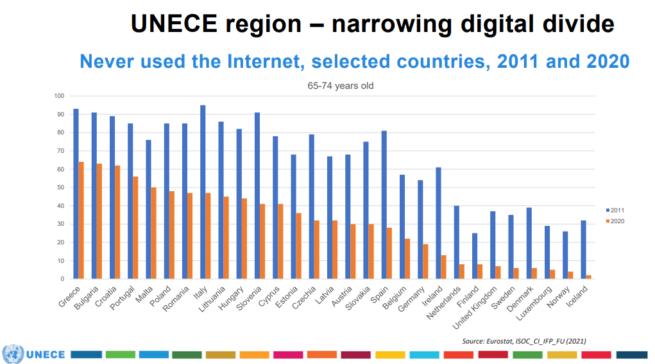

Another internet-based survey published in 2021, explored the generational differences as related to self-perceived eHealth literacy and health care system utilization. The main variables include IHISB (internet health information seeking behavior), eHL (measured by eHEALS), the self-perceived gain in empowerment by that information and the number of health care appointments in the previous year. The main findings of the study are the following:
- Hungarians between the age of 18 and 72 searched health information on the Internet equally frequently, the elder among them had fewer digital skills in finding information on the Web
- older generations possess lower eHEALS score than younger ones
- eHEALS score positively correlated with IHISB across all generations
- the averaged frequency of IHISB affects the utilization of the health care system in Generation X and Baby boomers, but eHEALS score does not
- subjects who use the Internet more frequently to search for health information have worse self-rated health status, the ones with higher eHEALS score report
- better subjective health status Generation Z gained the least empowerment from using the internet
It seems that younger generations need development in decision-making skills, while older ones who usually need the most medical attention, need to be taught the effective use of the internet, electronic health information and services.

National statistics on ICT use: current number of households having access to the Internet, equipped with a computer, landlines, mobile lines, measured popularity of e-health resources, special focus on seniors

In 2017, the proportion of households with Internet access was 82% in Hungary, which is
It was 5.0 percentage points lower than the EU average (87%), a difference of 1 percentage point. Compared to 2016. The proportion of Internet users in Hungary within 3 months is 77%, with 7 percentage points less than the EU-28 average (84%).
In 2017, the number of mobile phone subscriptions decreased by 0.5%, at the same time the monthly fee subscriptions continued to grow. The saturation of the mobile market with increasingly favorable tariff plans which also influenced the large increase in data traffic.
In 2017, the number of Internet subscriptions increased by 5.3% compared to the previous year. The mobile internet accounted for more than two-thirds (69%) of all Internet subscriptions, up 0.3 percentage points in one year rose. Within Internet subscriptions, cable TV subscriptions have risen, while xDSL slightly decreased. At the same time, the significantly expanding optical Internet must be considered.

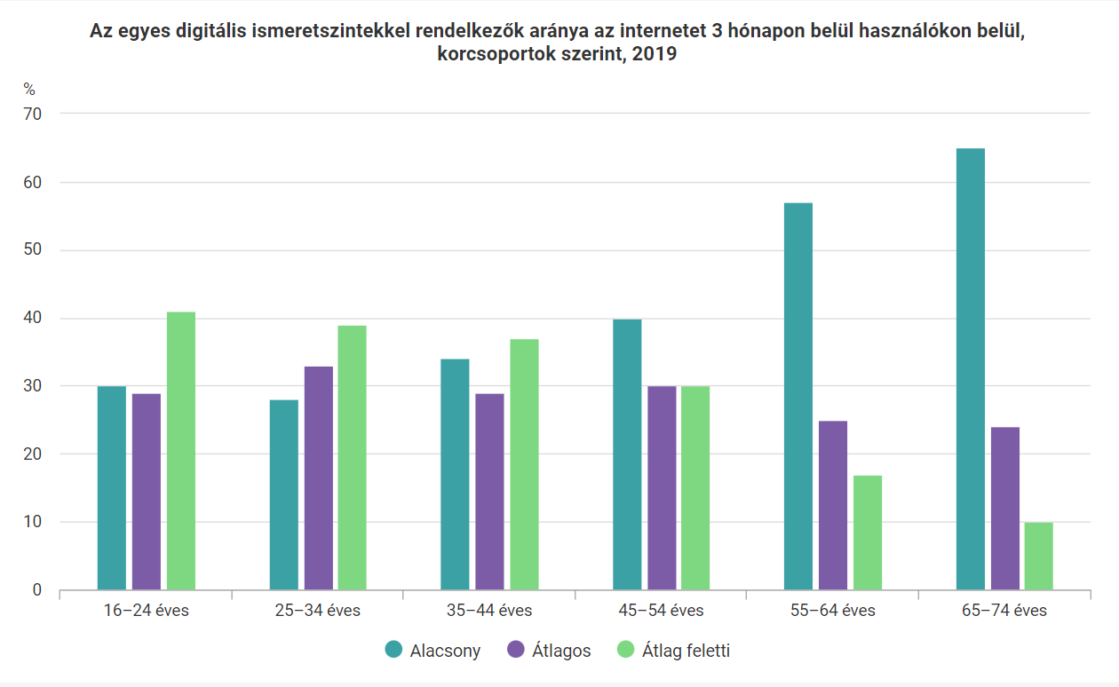

In 2020, 88% of Hungarian households already had Internet access, so we moved closer to the EU average. Eighty-five percent of 16- to 74-year-olds who have accessed the Web for private purposes have used the Internet within three months, and 44% of 65-74-year-olds have already used the online space daily for private purposes.

The proportion of EU citizens' private internet activity followed the trend of previous years, with the highest rates for sending and receiving e-mail (85%), searching for information on goods and services (80%), and using instant messaging (79%), and used the World Wide Web to read online news (75%). Among Hungarian Internet users, these were also the most frequently performed online activities, as well as participation in social networking sites with a share of 87%, which is the highest, 22 percentage points higher than the EU average (65%).
In 2020, internet search for products and services accounted for a high proportion of the 45-54 and 55-64 age groups (90 and 85%).
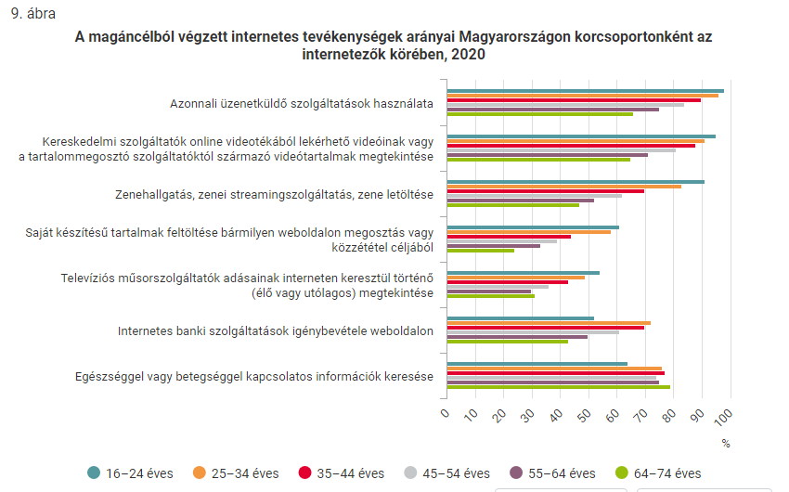

The range of health services available via the Internet is a gradually expanding area that can provide fast, reliable services to residential users in a variety of life situations (eg online systems played a significant role in contacting GPs and specialist clinics in 2020). 28% of Hungarian Internet users used the Internet to register for a medical examination at a health care institution, and one-fifth to access their personal health data. Instead of visiting health care facilities in person, 21% of Internet users sought an online consultation or a prescription.

Main findings | - The population of Hungary is aging. This is more due to low birth rates than an increase in life expectancy. As a result, the size of the population is decreasing. In 1990 the 13% of population was above age 65 year, in 2020 it achieved 20%. According to forecasts, the number of people over the age of 65 in Hungary will reach a 29% of the population in 2030.  - There are big differences in the numbers in some regions of the country, which also means that a different solution will have to be found to care for the elderly in urban area where their proportion is the lowest, and in rural area, where it is the highest  - Based on a Health Literacy Survey's results, although the understanding of health in Hungary is similar to the trends in other European countries, its extent somewhat lower than that. More than half of Hungary’s 16 or older population has only limited health literacy  - In another study, 14.3% of the respondents had either inadequate or marginal health literacy (8.3% inadequate, 6% marginal health literacy scores). The results are in accordance with the European outcomes of the S-TOFHLA, as in many countries the proportion of either marginal or inadequate health literacy was around 10 to 15%.  - Regarding the socio-demographic predictors, the results show that older participants possess a lower level of health literacy, which is in accordance with previous findings. As chronically ill needs to use and understand health-related information on a regular basis, it is crucial to increase the health literacy level in this population.  - Research in 2020 has shown that the participants find the health care systems complex, expensive, and difficult to access. As a result, they often do not seek the care they know they would need. Also, although experiencing problems with navigating the health care systems first-hand, the participants did not feel empowered to change these systems but rather felt they had to endure them.  - Based on the data of 2010–2018, a quarter of the population in Hungary feels limited in terms of everyday activities.  - As a survey conducted in 2015 found that about half of Hungarians did not have adequate health education, there would be a need for effective policy measures that would hopefully improve the health status of the population and the overburdening of the health care system  - In 2020, 88% of Hungarian households already had Internet access. 28% of Hungarian Internet users used the Internet to register for a medical examination at a health care institution, and one-fifth to access their personal health data. Instead of visiting health care facilities in person, 21% of Internet users sought an online consultation or a prescription.  - However, due to physical isolation during the Covid-19 pandemic the internet became a major contact channel regarding all aspects of life and the Eurostat data shows significant increase in internet usage also among the 65-74 years old population there was still high proportion (appr. 45%) of Hungarian older adults who never used internet in 2020.

The publications found during the desk-research:

YEAR | TITLE | AIM | link
2016 | "So that each patient may comprehend": measuring health literacy in Hungary | to translate and adapt the Hungarian version of the Short-Test of Functional Health Literacy and the perception-based Chew screening questions | LINK
2016 | The practical measurement of health literacy in Hungary and in international comparison | To show the level of practical health literacy in the Hungarian society and in international comparison (following HLS-EU Q47, index calculation and thresholds) | LINK
2016 | Pharmaceutical counseling of non-conventional dosage forms concerning the health-literacy and the patient adherence in public medication dispensing -Questionnaire surveys in Hungarian community pharmacies | The counseling and advices can improve the patients' knowledge concerning application rules of different new dosage forms (health- literacy) with patient adherence. | LINK
2016 | Hungarian health literacy in international comparison | to present the extent of the practical health literacy in  the Hungarian society and its place in international comparison | LINK
2017 | An empirical test of the Health Empowerment Model: Does patient empowerment moderate the effect of health literacy on health status? | The Health Empowerment Model (Schulz & Nakamoto, 2013) advocates that the effects of health literacy and empowerment are intertwined on health outcomes. This study aims to test this assumption in the context of health status as a patient outcome. | LINK
2017 | The role of patient support programs in health literacy of patients. results of a 1.5-year-long Hungarian study | to determine the effectiveness of a specialized patient support program in Hungary. | LINK
2018 | Measuring the factors affecting health literacy in East Hungary – Health literacy in the adult population of Nyíregyháza city | to measure health literacy and find the factors affecting it among the adult population | LINK
2018 | Validity of Three Brief Health Literacy Screeners to Measure Functional Health Literacy - Evidence from Five Different Countries | replicating the original validation of the BHLS. | LINK
2019 | Measuring functional health literacy in Hungary: Validation of S-TOFHLA and Chew screening questions | to validate the Short Test of Functional Health Literacy (S-TOFHLA) and the Chew screening measure  to provide an overview of the health literacy level of the Hungarian population. | LINK
2019 | Psychometric properties of the Hungarian version of the eHealth Literacy Scale | to test the Hungarian version of eHEALS | LINK
2019 | The Rise of the Empowered Physician in the Digital Health Era: Viewpoint |  | LINK
2019 | Patient behavior and social support – whether the health literacy can  influence the adherence of patients | The aim of ABC study was complex, from  finding consensus in definition of adherence to the recommendations to healthcare policy  regarding improvement of adherence of patients. | LINK
2019 | Opinion leader empowered patients about the era of digital health: a qualitative study | to explore the opinion leader empowered patients' relationship with their medical professionals, their experiences, and beliefs about technologies, and how they see the future. | LINK
2020 | Health Literacy in the Everyday Lives of Older Adults in Greece, Hungary, and the Netherlands | to explore the context-specific perspectives of older adults and health professionals on HL in later life | LINK
2020 | Health literacy among participants from neighborhoods with different socio-economic statuses in the southern region of Hungary: a pilot study | (1) conduct a pilot study among the population of Baranya County with different socio-economic statuses,  (2) evaluate the HL level  (3) found the correlations between socio-economic data, emergency departments' visits, medical history, and HL. | LINK
2020 | Establishment of a communication environment supporting low-health literacy in the Hungarian community pharmacies: the introduction of a methodological recommendation: a before-after study | to support the effectiveness and necessity of the communication training and methodology introduced in the postgraduate pharmacy training and community pharmacy practice in Hungary. | LINK
2020 | Antecedents of use of e-health services in Central Eastern Europe: a qualitative comparative analysis | to identify the key conditions that positively affect the use of e-health services in Central Eastern Europe (CEE) countries | LINK
2020 | Exploring eHealth Literacy and Patient-Reported Experiences With Outpatient Care in the Hungarian General Adult Population: Cross-Sectional Study | to explore the relationship between eHealth literacy and patient-reported experience measures (PREMs) among users of outpatient care in Hungary | LINK
2021 | Generation Gaps in Digital Health Literacy and Their Impact on Health Information Seeking Behavior and Health Empowerment in Hungary | to explore generational differences as related to self-perceived eHealth literacy and health care system utilization | LINK
2021 | Recursive Path Model for Health Literacy: The Effect of Social Support and Geographical Residence | investigate geographical differences regarding the levels of health literacy and its determinants | LINK
2021 | Validation of health literacy questionnaires in Hungarian adult sample | validate the Hungarian version of two instruments measuring health literacy: the performance-based Newest Vital Sign and the self-reported Brief Health Literacy Screening Tool | LINK
2021 | Health literacy and behavioral health factors in adults | to examine the relationship between health literacy (HL) and health behaviors | LINK
2021 | Building a House of Skills-A Study of Functional Health Literacy and Numeracy among Patients with Type 2 Diabetes in Hungary | to explore functional health literacy (FHL) and numeracy skills in an insulin-treated, type 2 diabetes mellitus (T2DM) patient population, and their impact on diabetes self-care activities | LINK
2021 | Health literacy and behavioral health factors in adults | to examine the relationship between health literacy (HL) and health behaviors in the South Bohemia Region and compare them to HL and health behaviors in the Visegrád group countries (Czech Republic, Hungary, Poland, and Slovakia). | LINK
2021 | Communicative health literacy of Hungarian adults – who are the most vulnerable? | provide a snapshot of communicative health literacy and determine the most vulnerable groups | LINK

Sources | Állami Számvevőszék (2022). A COVID-19 járvány hatása az egészségügyi e-szolgáltatások fejlődésére és elterjedésére. https://www.asz.hu/storage/files/files/elemzesek/2022/Elemzes_COVID_19_egeszsegugyi_e_szolg.pdf?ctid=1259  De Wit, L., Karnaki, P., Dalma, A., Csizmadia, P., Salter, C., de Winter, A., & Meijering, L. (2020). Health Literacy in the Everyday Lives of Older Adults in Greece, Hungary, and the Netherlands. International journal of environmental research and public health, 17(7), 2411. https://www.ncbi.nlm.nih.gov/pmc/articles/PMC7177367/  Emberi Erőforrások Minisztériumának Egészségügyért Felelős Államtitkársága. (2021) „Egészséges Magyarország 2021−2027” Egészségügyi Ágazati Stratégia. https://mok.hu/public/media/source/Transzparencia/Allasfoglalasok/Eg%C3%A9szs%C3%A9ges%20Magyarorsz%C3%A1g%202021%E2%88%922027%20Eg%C3%A9szs%C3%A9g%C3%BCgyi%20%C3%81gazati%20Strat%C3%A9gia.pdf  European Commission (2017). State of Health in the EU. Magyarország Egészségügyi országprofil. https://ec.europa.eu/health/system/files/2017-12/chp_hu_hungary_0.pdf  European Commission (2021). State of Health in the EU Hungary https://ec.europa.eu/health/system/files/2021-12/2021_chp_hu_english.pdf  Innovációs és Technológiai Minisztérium, Belügyminisztérium. (2020) Nemzeti digitalizáció stratégia. https://2015-2019.kormany.hu/download/f/58/d1000/NDS.pdf  Koltai, J., Kun, E. (2016) The practical measurement of health literacy in Hungary and international comparison. Orv. Hetil., 157(50), 2002–2006 http://real.mtak.hu/46535/1/650.2016.30563.pdf  Központi Statisztikai Hivatal. (2019) Egészségügyi helyzetkép https://www.ksh.hu/docs/hun/xftp/idoszaki/pdf/egeszsegugyi_helyzetkep_2019.pdf  Központi Statisztikai Hivatal. A háztartások információs- és kommunikációseszköz-használatának főbb jellemzői. https://www.ksh.hu/docs/hun/xftp/idoszaki/ikt/2020/01/index.html  Központi Statisztikai Hivatal. A várható élettartam. https://www.ksh.hu/ffi/1-10.html  Központi Statisztikai Hivatal. Digitális ismeretek. https://www.ksh.hu/ffi/1-23.html  Központi Statisztikai Hivatal. Fenntartható fejlődési célok. Az aktív korúak és idősek aránya. https://www.ksh.hu/sdg/4-19-sdg-1.html  Központi Statisztikai Hivatal. Population of Hungary by sex and age. https://www.ksh.hu/interaktiv/korfak/orszag.html  Libicki É., R. Fedor A., (2020). A multi-level approach for the research background of subjective health condition in view of social inequalities. University of Debrecen faculty of health. https://ojs.lib.unideb.hu/ams/article/view/8509/7740  Magyarország átfogó egészségvédelmi szűrőprogram 2010-2020-2030 (MÁESZ) https://egeszsegprogram.eu/  Mátyás G. (2020) Cikkismertetés: Hogyan növelhető bizonyított hatékonysággal az egészségműveltség? http://epa.oszk.hu/02900/02987/00020/pdf/EPA02987_egeszsegfejlesztes_2020_01_072-076.pdf  Monostori J., Őri P., Spéder Z. (2015). Demographic portrait 2015. Report on the situation of the Hungarian Population. https://www.demografia.hu/kiadvanyokonline/index.php/demografiaiportre/article/view/2484/2163  OECD Economic Surveys: Hungary (2021) https://www.oecd.org/economy/surveys/Hungary-2021-OECD-economic-survey-overview.pdf  Office of Disease Prevention and Health Promotion. Health Literacy in Healthy People 2030. https://health.gov/healthypeople/priority-areas/health-literacy-healthy-people-2030  Papp-Zipernovszky O, Horváth MD, Schulz PJ and Csabai M (2021) Generation Gaps in Digital Health Literacy and Their Impact on Health Information Seeking Behavior and Health Empowerment in Hungary. Front. Public Health https://www.frontiersin.org/articles/10.3389/fpubh.2021.635943/full  Papp-Zipernovszky, O., Náfrádi, L., Schulz, P. J., Csabai, M. (2016) “So each patient comprehends”: measuring health literacy in Hungary. Orv. Hetil., 157(23), 905–915. http://real.mtak.hu/35947/1/650.2016.30412.pdf  Sørensen, K., Van den Broucke, S., Fullam, J., Doyle, G., Pelikan, J., Slonska, Z., Brand, H., & (HLS-EU) Consortium Health Literacy Project European (2012). Health literacy and public health: a systematic review and integration of definitions and models. BMC public health, 12, 80. https://www.ncbi.nlm.nih.gov/pmc/articles/PMC3292515/#  Szabó P., Kósa K. (2016) Egészségműveltség a magyar népesség körében. OTSZonline. http://otszonline.hu/egeszsegugyeink/cikk/egeszsegmuveltseg_a_magyar_nepesseg_koreben  Tarcza O. (2020). Vészjósló elöregedés: társadalmi és szakmai diskurzusra lenne szükség. Medicalonline. http://medicalonline.hu/eu_gazdasag/cikk/veszjoslo_eloregedes__tarsadalmi_es_szakmai_diskurzusra_lenne_szukseg  Zrubka, Z. A magyar nyelvű Elektronikus Egészségműveltség Skála (eHealth Literacy Scale; eHEALS) mérési tulajdonságainak vizsgálata. https://www.uni-corvinus.hu/contents/uploads/2020/10/Digit%C3%A1lis%20eg%C3%A9szs%C3%A9gm%C5%B1velts%C3%A9g.f16.pdf  Zrubka, Z., Hajdu, O., Rencz, F. et al. (2019) Psychometric properties of the Hungarian version of the eHealth Literacy Scale. Eur J Health Econ 20, 57–69. https://link.springer.com/article/10.1007/s10198-019-01062-1

The project is co-financed by the Governments of Czechia, Hungary, Poland and Slovakia through Visegrad Grants from International Visegrad Fund. The mission of the fund is to advance ideas for sustainable regional cooperation in Central Europe.

Központi Statisztikai Hivatal, Population of Hungary by sex and age
Monostori, et al., 2015
Innovációs és Technológiai Minisztérium, Belügyminisztérium, 2020
Központi Statisztikai Hivatal. Fenntartható fejlődési célok
European Commission, 2021
European Commission, 2017
Központi Statisztikai Hivatal. A várható élettartam
Tarcza, 2020
Sørensen, et al., 2012
Office of Disease Prevention and Health Promotion
Sørensen, et al., 2012
Libicki, et al., 2020
Szabó, et al., 2016
Sørensen, et al., 2012
Koltai, et al., 2016
Papp-Zipernovszky, et al., 2016
De Wit, et al., 2020
De Wit, et al., 2020
Központi Statisztikai Hivatal, 2019
Központi Statisztikai Hivatal, 2019
Szabó, et al., 2016
Mátyás, 2020
Emberi Erőforrások Minisztériumának Egészségügyért Felelős Államtitkársága, 2021
Magyarország átfogó egészségvédelmi szűrőprogram 2010-2020-2030
OECD Economic Surveys: Hungary, 2021
Állami Számvevőszék, 2022
Zrubka. A magyar nyelvű Elektronikus Egészségműveltség Skála (eHealth Literacy Scale; eHEALS) mérési tulajdonságainak vizsgálata
Zrubka, et al., 2019
Papp-Zipernovszky, et al., 2021
Központi Statisztikai Hivatal. Digitális ismeretek
Központi Statisztikai Hivatal. A háztartások információs- és kommunikációseszköz-használatának főbb jellemzői

